WEEK 2: GLOBALISATION
***
Part1: Social Interaction (3’)
Let’s talk about festivals:
- What is your favorite festival?
My favorite festival is Tet Nguyen Dan. It's a time for family gatherings, enjoying delicious food, and sharing joy after a year of hard work. Not only that, Tet also brings me a sense of peace and hope for a lucky new year.
- What are the most popular Vietnamese festivals?
The most popular Vietnamese festivals include Lunar New Year and Mid-Autumn Festival. Each of these festivals holds cultural and historical significance in Vietnam, celebrated with traditional rituals, delicious food, and vibrant festivities.
- Do you like western festivals?
As a Vietnamese, I find them fascinating! While they may not hold the same cultural significance for me personally, I enjoy learning about different traditions and customs. Plus, who can resist the joy of Christmas lights or the excitement of Halloween?

Let’s talk about weddings:
- What presents are suitable for a wedding in your country?
Suitable presents for a wedding in Vietnam often include practical items for the couple's new life together, such as household appliances, kitchenware, or decorative items for their home. Or we just give money and wishes
- Do you think money spent on a wedding is wasted?
I don't believe money spent on a wedding is wasted, but it's essential to strike/ make it a balance. While weddings are special occasions to celebrate love and commitment, overspending can lead to unnecessary financial strain/dept. It's important for couples to prioritize what truly matters to them and find ways to celebrate within their means.
- What is your idea of an ideal wedding party?
My idea of an ideal wedding party is one filled with genuine love, laughter, and unforgettable moments shared with family and friends. May be I will organize at the church near my house or in a fancy restaurant, It depends.

Part 2: Solution Discussion (4’)
Situation: You're shopping at a local market, and you notice a variety of products from different countries on the shelves. There are 3 options: buying products from different parts of the world, choosing among so many unfamiliar products, or sticking to familiar local products. Which one would you choose? What are the reasons for your choice?
Among….I choose buying from different parts.
In my opinion. Trying products from different countries allows me to experience a variety of cultures right in my local market. It's a way to broaden my horizons/ my knowledge and learn about the traditions, flavors, and ingredients unique to each region.
By buying goods from different nations, I'm helping global trade and backing small-scale producers and craftsmen worldwide. It's a means to acknowledge and celebrate the interdependence of our world.
Overall, while sticking to familiar local products has its merits, it might shorten my range of knowledge.
In conclusion…

Part 3: Topic Development (5’)

Topic: There are several benefits of globalization.

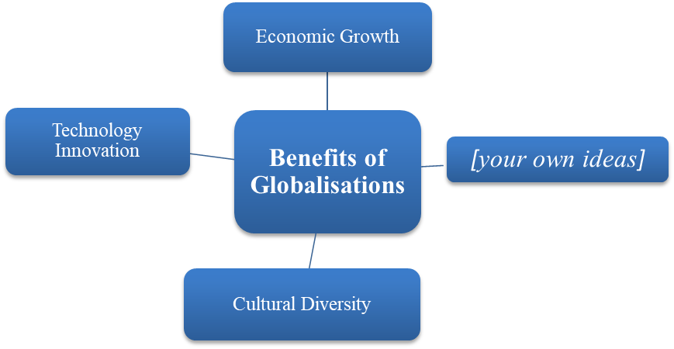
As a result of the progress in the global economy and international relationship, globalization is the present trend in every country. The truth is that globalization brings about a varity of benefits
Firstly, An open economy helps a country develop rapidly through foreign investment. It allows developed countries to invests into the developing ones for a cheaper labour cost, which consequently lower the products cost for everyone. Moreover/ In addition, because of the exchange rate differences, the foreign also help citizens improve their livelihood.
Secondly, globalization provides various technology innovation. By exchanging knowledge between countries, many projects bring about promising result, practical product, Internet is the obvious result, it has became one of the most important part of our life.
Thirdly, it also come up with cultural diversity. By exchanging cultural, we can broaden our horizons/ my knowledge and learn about the traditions, flavors, and ingredients unique to each region. It play a paramount role in breaking down barriers in numerous aspects of life/ fields.
In conclusion, Globalisation have wide range of advantages, it grown the economic, provide technology innavation, and help us learn about cultaral of all over the world

Follow-up questions:
- Can you discuss the influence of globalization on job opportunities for Vietnamese citizens?
Vietnam is a developing country so it interact many developed contries to invest . And thanks to globalization, in the present day, Vietnam has foreign factories and they has employ local labour. It notably helps improve the citizen income.

- How has globalization contributed to the growth of the tourism industry in Vietnam?
Globalization makes foreigner travel to Vietnam easier than ever as long as they have a qualified visa. Because foreigner currency it worth more than Vietnamdong,, I think I have significantly improve the tourism industry.

